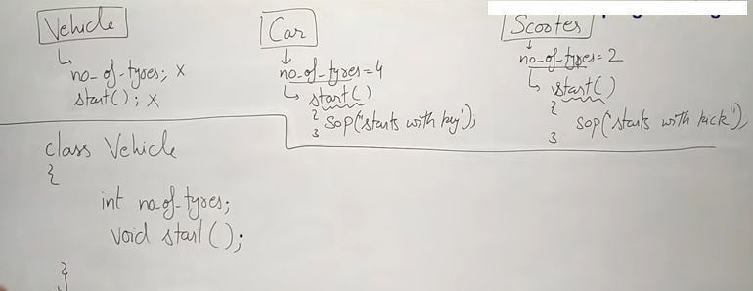


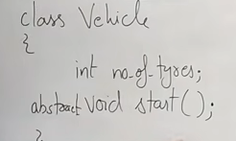



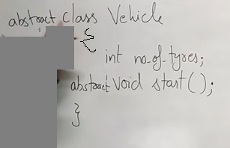

**But if a class is declared with abstract it may contain simple methods



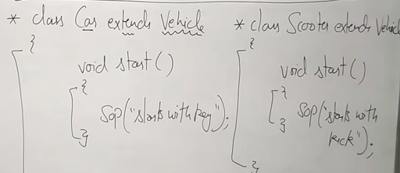



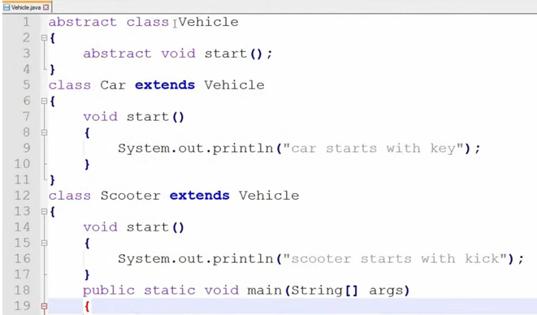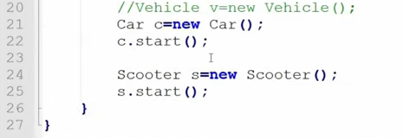

Abstract class in Java
A class which is declared as abstract is known as an abstract class. It can have abstract and non-abstract methods. It needs to be extended and its method implemented. It cannot be instantiated.

Points to Remember
- An abstract class must be declared with an abstract keyword.
- It can have abstract and non-abstract methods.
- It cannot be instantiated.
- It can have constructors and static methods also.
- It can have final methods which will force the subclass not to change the body of the method.

Interface in Java
- An interface in Java is a blueprint of a class. It has static constants and abstract methods.
- The interface in Java is a mechanism to achieve abstraction. There can be only abstract methods in the Java interface, not method body.

Why use Java interface?
There are mainly three reasons to use interface. They are given below.
- It is used to achieve abstraction.
- By interface, we can support the functionality of multiple inheritance.
- It can be used to achieve loose coupling.

How to declare an interface?
An interface is declared by using the interface keyword. It provides total abstraction; means all the methods in an interface are declared with the empty body, and all the fields are public, static and final by default. A class that implements an interface must implement all the methods declared in the interface.

Syntax:
interface <interface_name>{

// declare constant fields
// declare methods that abstract
// by default.
}

In other words, Interface fields are public, static and final by default, and the methods are public and abstract.

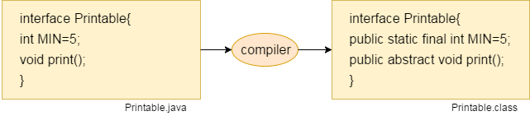

The relationship between classes and interfaces
As shown in the figure given below, a class extends another class, an interface extends another interface, but a class implements an interface.

abstract class Bank{  abstract int getRateOfInterest();  }  class SBI extends Bank{  int getRateOfInterest(){return 7;}  }  class PNB extends Bank{  int getRateOfInterest(){return 8;}  }  class TestBank{  public static void main(String args[]){  SBI b=new SBI();  System.out.println("Rate of Interest is: "+b.getRateOfInterest()+" %");  PNB p=new PNB();  System.out.println("Rate of Interest is: "+p.getRateOfInterest()+" %"); }} | interface Bank{  float rateOfInterest();  }  class SBI implements Bank{  public float rateOfInterest(){return 9.15f;}  }  class PNB implements Bank{  public float rateOfInterest(){return 9.7f;}  }  class TestBank1{  public static void main(String args[]){  SBI b;  b=new SBI();  System.out.println("Rate of Interest is: "+b.rateOfInterest()+" %");  PNB c=new PNB();  System.out.println("Rate of Interest is: "+c.rateOfInterest()+" %");  }}

